Shaan Barkat

Mr. Grady

IT 223

15 January 2017

Assignment #2

1.1: A score of 44.3 is needed to reach the 93rd percentile or above.

1.2: 60% of students will achieve a score of at least 55.2.

1.3: The percentage of students that will score between 380 and 580 is 2.3%.

2.1:

52.00, 97.00, 112.00, 112.00, 115.00, 117.00, 121.00, 123.00, 124.00, 127.00, 129.00, 132.00, 137.00, 172.00

2.2:

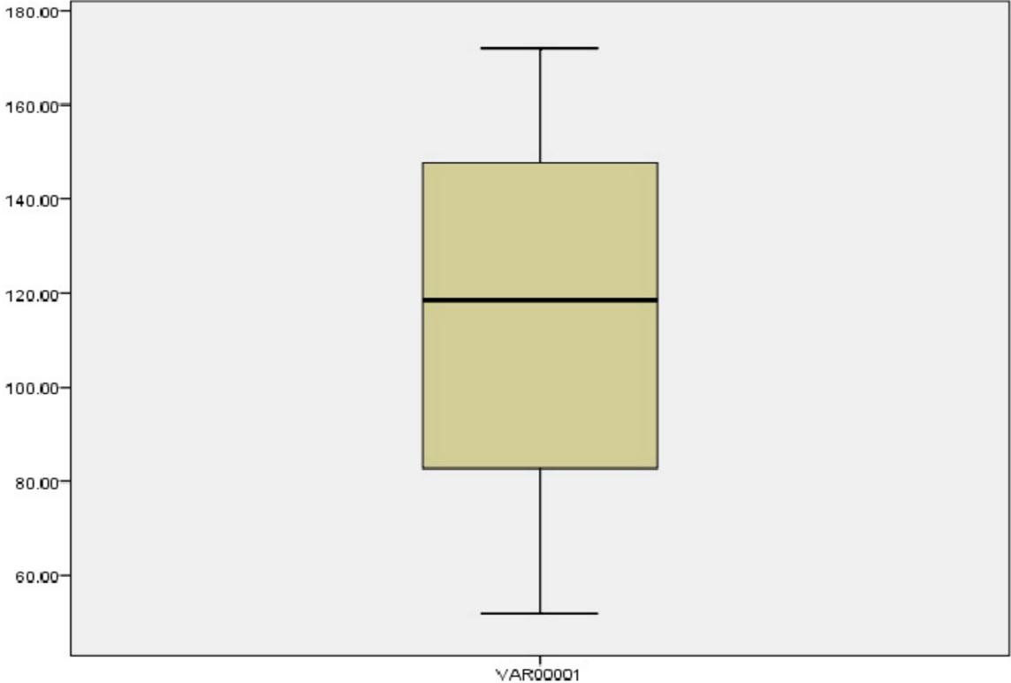

2.3: 52, 113.50, 123.50, 172

2.4: I never encountered any “starred” datapoint.

3.1:

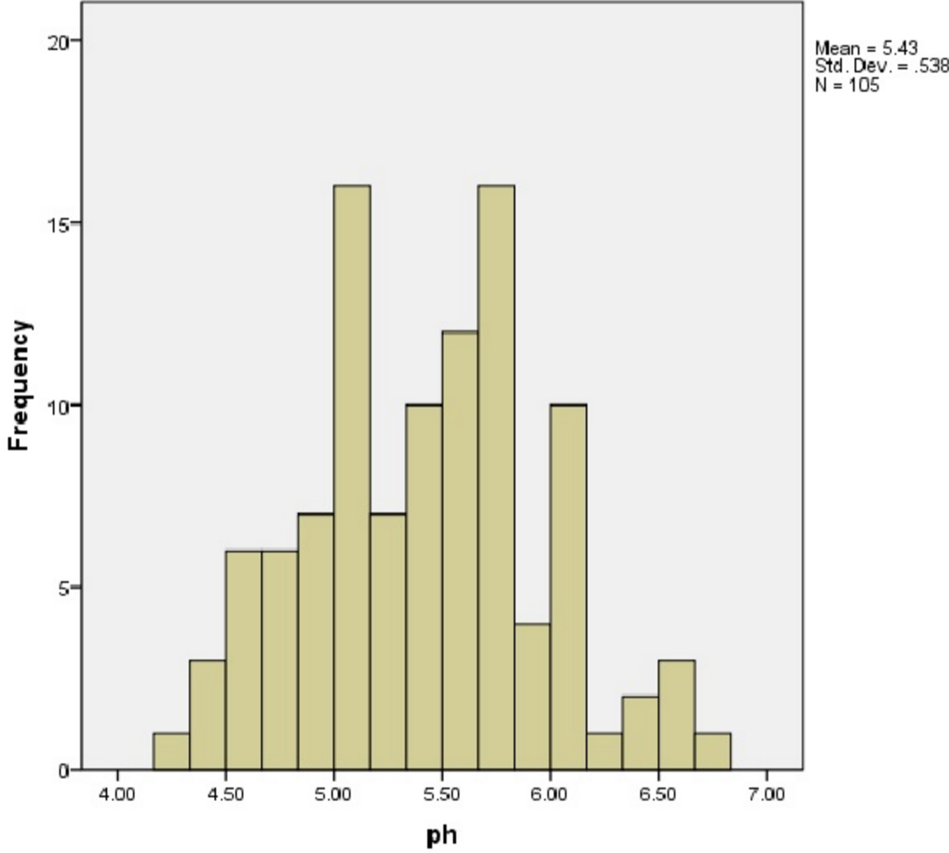

3.2: Mean = 5.43 ; SD = .538

3.3: 30% of rainwater measured that had a pH of 4.9 or lower.

4.1:

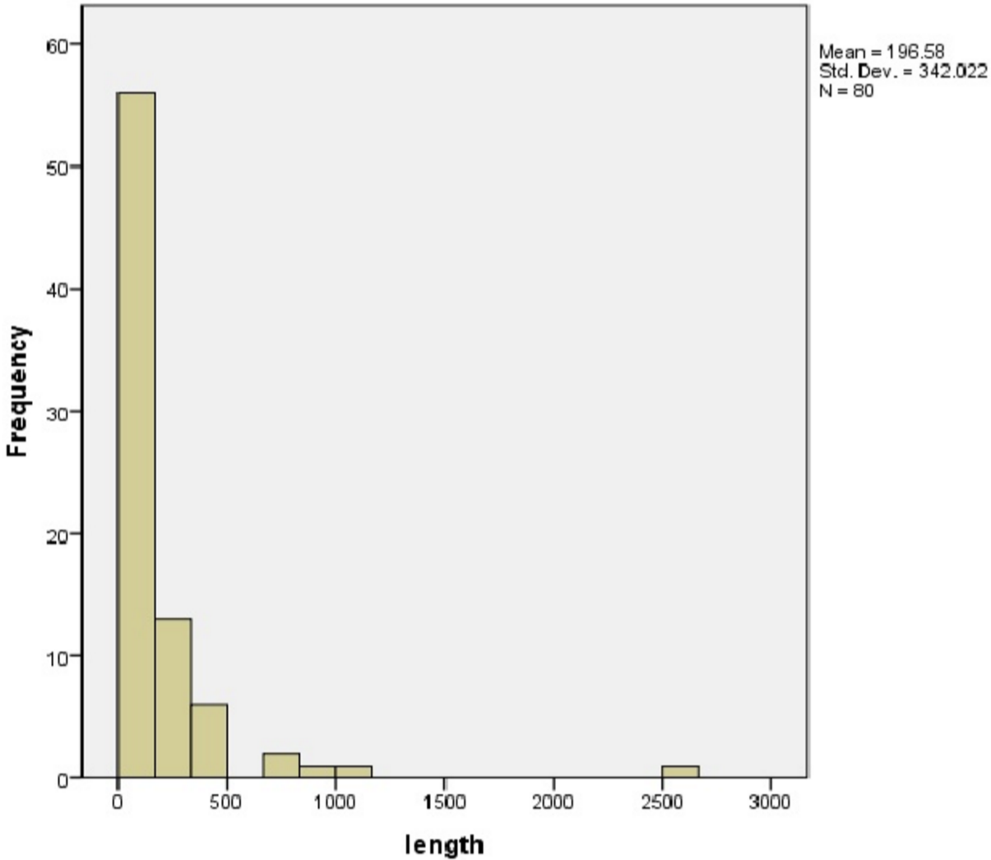

4.2: Mean = 196.58 ; SD = 342.022

4.3: about 70 calls lasted longer than 4 minutes.